Service Folder
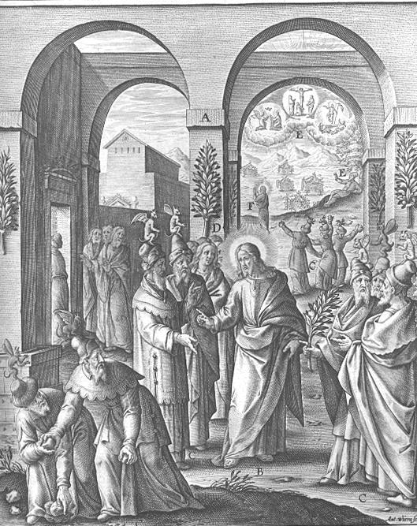
Judica – Fifth Sunday in Lent
“Vindicate me, O God!”
March 18, 2018

Emmanuel Lutheran Church
4675 Bataan Memorial West
Las Cruces, New Mexico 88012
(575) 382-0220 (church office) / (575) 636-4988 (pastor cell)
www.GodWithUsLC.org

Sts. Peter & Paul Lutheran Mission
Silver City, New Mexico
www.peterandpaullutheran.org

Rev. Paul A. Rydecki, Pastor
member of the Evangelical Lutheran Diocese of North America (ELDoNA)

ANNOUNCEMENTS
Welcome! Emmanuel is a liturgical, traditional, historical, evangelical, catholic, orthodox, confessional Lutheran congregation, in communion with the Evangelical Lutheran Diocese of North America (ELDoNA). We believe that the Bible is the very Word of God, inspired and without any errors. We confess the truth of Scripture according to the Lutheran Book of Concord of 1580, without exception or reservation. We observe the calendar of the traditional Church Year and follow the Historic Lectionary. We celebrate the Divine Service (also known as the Mass) every Sunday and on other festivals, and we welcome visitors to hear God’s Word with us.
With regard to Holy Communion, we ask our visitors to respect our practice of closed Communion, which means that only communicant members of our congregation or of other congregations in communion with us are invited to commune at the Lord’s Table here, after they have been examined and absolved. Classes are offered throughout the year by the pastor so that those who are interested in joining our Communion fellowship have the opportunity to learn about the Christian faith and our confession of it.
The Order of Service is The Order of Holy Communion (page 15) from The Lutheran Hymnal (TLH). The Scriptures are read from the New King James Version (NKJV). The Propers (the parts that change from week to week) are noted on the following page of this Service Folder.
The Gloria Patri (Glory Be to the Father) is omitted from today through Good Friday. Note this especially at the end of the Nunc Dimittis.

EVENTS IN THE NEAR FUTURE…
Tues., Mar. 20 - The Passion of the Christ movie, 6 PM
Wed., Mar. 21 - Supper, 5:45 PM; Vespers, 6:30 PM
Sun., Mar. 25 - Bible class & Sunday School 9 AM
- Divine Service 10:15 AM (Palm Sunday)
Mon., Mar. 26 - Passion History Reading, 6:30 PM
Tues., Mar. 27 - Passion History Reading, 6:30 PM
Thur., Mar. 29 - Maundy Thursday Divine Service, 6:30 PM
Fri., Mar. 30 - Good Friday Divine Service, 1 PM
Sat., Mar. 31 - Easter Vigil, 8 PM
Sun., Apr. 1 - Easter breakfast, 8:30 AM
- Divine Service for the Feast of the Resurrection, 10:15 AM

PROPERS Lent 5 - Judica

HYMNS
OPENING HYMN TLH #151 – Christ, the Life of All the Living (st. 1-4)
HYMN (after the Creed) TLH #151 – Christ, the Life of All the Living (st. 5-7)
HYMN (after General Prayer) TLH #372 – Through Jesus' Blood and Merit
DISTRIBUTION HYMN TLH #306 – Lord Jesus Christ Thou Hast Prepared

Genesis 12:1-3 + Hebrews 9:11-15 + John 8:46-59

The service begins on page 15 of The Lutheran Hymnal (TLH).
THE INTROIT (after the general Absolution) Psalm 43:1-2a; Psalm 43:3a, 4-5
P (Antiphon) Vindi- | cate me, O God, *
And plead my cause against an un- | godly nation; __
Oh, deliver me from the deceitful | and unjust man! *
For You are the | God of my strength; __
C Oh, send out Your | light and Your truth! *
Let them lead me; let them bring me to | Your holy hill __.
P (Antiphon)
The service continues with The Kyrie, p. 17, followed immediately by the Salutation, p. 19.
GRADUAL (after First Lesson) & TRACT (after Epistle) Ps. 143:9-10, 18:48; 129:12
P Deliver me, O Lord, from | my enemies; *
Teach me | to do Your will. __
C He delivers me from my enemies. You also lift me up above those who | rise against me; *
You have delivered me from | the violent man. __
P “Many a time they have afflicted | me from my youth,” *
Let | Israel now say, __
C “Many a time they have afflicted | me from my youth; *
Yet they have not pre- | vailed against me.” __

The service continues on p. 21 with the reading of the Gospel.
We believe, teach and confess…

from the Formula of Concord, Solid Declaration: Article III
It is also correct to say that believers who have been justified through faith in Christ first have the righteousness of faith credited to them in this life. Then, they also have the initial righteousness of the new obedience or of good works. But these two types of righteousness must not be mixed with each other or both be injected into the article of justification by faith before God. For this initial righteousness or renewal in us is incomplete and impure in this life because of the flesh. A person cannot stand with and ‹on the ground of this righteousness› before God’s court. Before God’s court only the righteousness of Christ’s obedience, suffering, and death—which is credited to faith—can stand. So only for the sake of this obedience is the person pleasing and acceptable to God and received into adoption and made an heir of eternal life. (This is true even after his renewal, when he has already many good works and lives the best life.)
Here belongs also what St. Paul writes in Romans 4:3. Abraham was justified before God through faith alone, for the sake of the Mediator, without the cooperation of his works. This was true not only when Abraham was first converted from idolatry and had no good works, but also afterward, when he had been renewed by the Holy Spirit and adorned with many excellent good works (Genesis 15:6; Hebrews 11:8). Paul asks the following question in Romans 4:1–3: At that time, on what did Abraham’s righteousness before God rest for everlasting life, by which he had a gracious God and was pleasing and acceptable to Him?
He answers: To the one who does not work but trusts Him who justifies the ungodly, his faith is counted as righteousness, just as David speaks of the blessing of the one to whom God counts righteousness apart from works.
Therefore, even though people who are converted and believe ‹in Christ› have the beginning of renewal, sanctification, love, virtue, and good works, these cannot and should not be drawn into, or mixed with, the article of justification before God. This is so the honor due to Christ may remain with Christ the Redeemer and tempted consciences may have a sure consolation, since our new obedience is incomplete and impure.

God’s Word at Home:
Bible Reading: Ezra 8 – Nehemiah 10
Small Catechism: Baptism, First Bible Passages: John 3:16-18, John 3:36

